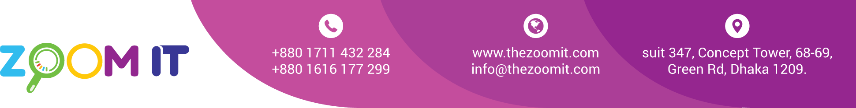

**Bill**

|  |  |
| --- | --- |
| Date | 13/04/2022 |
| INV. NO. | 1032 |

|  |  |
| --- | --- |
| Name | Miyako Appliance Limited |
| Address | Plot 50, Sector 3, Uttara, Dhaka 1230 |

|  |  |  |  |
| --- | --- | --- | --- |
| **Sl.**  **No.** | **Description** | **Type** | **Value in Taka** |
| 1  2 | Server bill  API Integration | Yearly  One time | 10,000  5000 |
|  | | Total | 15,000 |
| Paid |  |
| Due |  |

BANK Details

Ac Name: ZOOM DIGITAL AC NO: 2228119002279

Prime bank Racecourse Branch  
  
Bkash Personal 01711432284

Signature